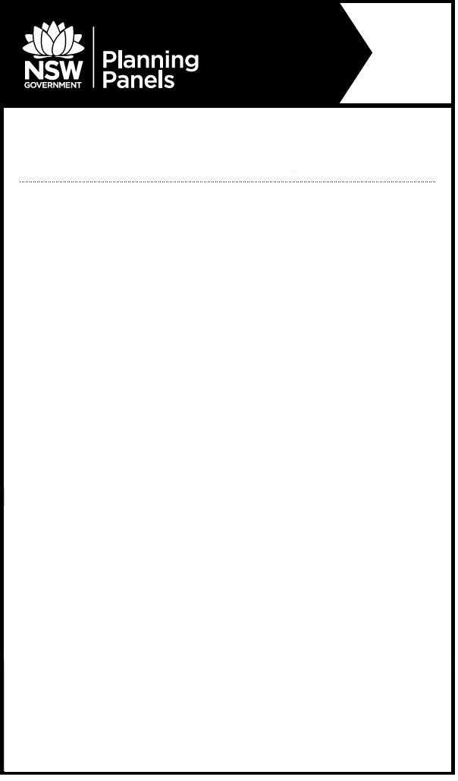

**Notice of Public Meeting**

**Sydney Western City**  **Planning Panel**

The panel will meet to determine the following:

* PPSSWC-124 – PENRITH – DA20/0858 – 5-7 Lawson Street, Penrith Construction of Part Nine (9) Storey & Part Five (5) Storey Mixed Use Building including 694 Public Car Parking Spaces, 37 Private Car Parking Spaces, 24 Motorcycle Parking Spaces & 42 Bicycle Parking Spaces (Basement Level & Ground Level to Level 4), Multi-Use Community Space, Public Rooftop Garden, Four (4) Storeys of Commercial Floor Space (Levels 5-8) & Related Demolition Works, Tree Removal, Ground Level Public Domain Works, Landscaping of Rooftop Garden & Land Re-Subdivision

**When:** Wednesday, 02 November 2022 at 10:00am

**Where:** The meeting will be held by public teleconference

Relevant documents will be available on the Planning Panels website [www.planningportal.nsw.gov.au/planningpanels](http://www.planningportal.nsw.gov.au/planningpanels) at least seven days before the meeting.

To register to speak or to listen to this meeting, please contact the Planning Panels Secretariat before 4pm on Monday, 31 October 2022 02 8217 2060 or email [enquiry@planningpanels.nsw.gov.au](mailto:enquiry@planningpanels.nsw.gov.au). You will be provided the phone number and code to enable you to join the public teleconference once registered.

Any person may listen to the public teleconference.

The panel is required to make an audio record of the meeting and make the recording publicly available on the Planning Panels website. You should be aware that this may include your personal information if you are presenting to the panel.

**For more information:** (02) 8217 2060

www.planningportal.nsw.gov.au/planningpanels